The Center for Transatlantic Relations
at the Paul H. Nitze School of Advanced International Studies
Johns Hopkins University
EU Center of Excellence Washington, DC

Transatlantic Leaders Forum

with
Pál Schmitt
President of the Republic of Hungary

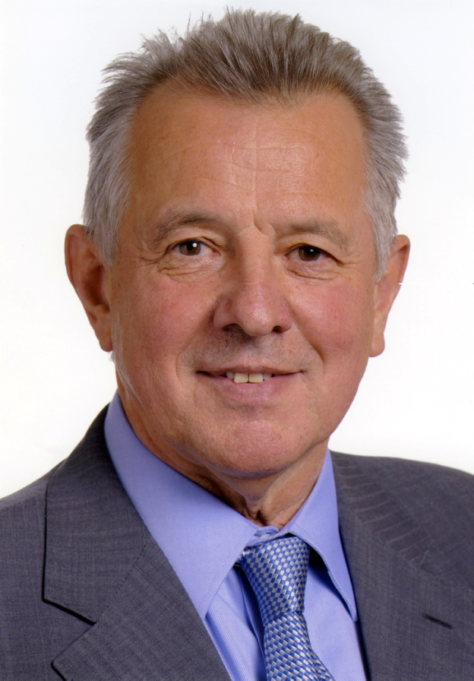

Why a Europe Whole and Free Still Matters:
A Central European Perspective

Amb. Kurt Volker, Moderator
Senior Fellow and Managing Director
Center for Transatlantic Relations

When: Friday, December 2, 2011
Time: 2:15 PM – 3:45 PM
Where: Kenney auditorium, 1740 Massachusetts Ave., NW, Washington DC

