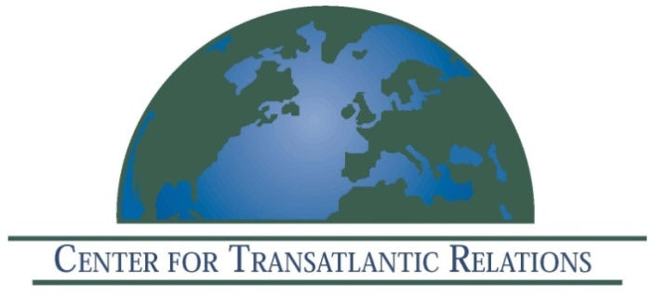

The Center for Transatlantic Relations, Johns Hopkins University
EU Center of Excellence Washington DC

Invites you to attend a book launch event

Transatlantic Energy Futures
Strategic Perspectives on
Energy Security, Climate Change and New Technologies
in Europe and the United States

Edited by
David Koranyi
Center for Transatlantic Relations

Thursday, December 8, 2011
9:30 am–11:50 am

Kenney Auditorium
1740 Massachusetts Avenue NW
Washington, DC 20036

9.30 – 9.40 Welcome by Daniel S. Hamilton, Director, Center for Transatlantic Relations

9.40 – 9.50 Introduction by David Koranyi, editor, Center for Transatlantic Relations
9.50 – 10.05 Keynote speech by Jonathan Elkind, Principal Deputy Assistant Secretary of Policy and International Affairs, U.S. Department of Energy

10.05 – 11.05 Panel I: Natural Gas and Transatlantic Energy Security

Moderator: David Koranyi, Center for Transatlantic Relations

Frank Umbach, Senior Associate and Head of the Programme “International Energy Security” at the Centre for European Security Strategies(CESS, GmbH) and Associate Director at the European Centre for Energy and Resource Security (EUCERS) at King's College, Cambridge

Taras Kuzio, Non-Resident Fellow, Center for Transatlantic Relations

Adnan Vatansever, Senior Associate in the Energy and Climate Program at the Carnegie Endowment for International Peace

Kornél Andzsans-Balogh, Researcher, Regional Center for Energy Policy Research (REKK)

11.05 – 11.50 Panel II: Renewables, innovation and new technologies

Moderator: Kurt Volker, Managing Director, Center for Transatlantic Relations

Mark Olsthoorn, Visiting Scholar, University of Maryland, Center for Integrative Environmental Research (CIER)

Pal Belenyesi, Visiting Scholar, Florence School of Regulation at the European University Institute

Michael Stanton-Geddes, Center for Transatlantic Relations

Dominic Marcellino, Research Fellow, Ecologic Institute, Washington, D.C.

12.00 Lunch

