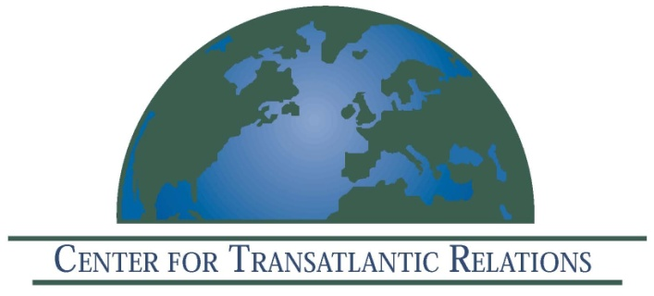

The Center for Transatlantic Relations, Johns Hopkins University-SAIS
EU Center of Excellence, Washington, DC
and
The Cournot Centre, Paris

Invites you to a book launch:

Europe’s Economic Crisis
Robert M. Solow and Daniel S. Hamilton, Editors

Nobel Prize Laureate Robert M. Solow and other distinguished experts address Europe's economic challenges in this new book. Will Europe’s economic crisis be remembered as the moment when the EU finally cracked? Or as the spur to a more integrated and competitive Union? What does it mean for the United States? Copies of the book will be available.

Wednesday, December 7, 2011
9:30 am–12:30 pm

Kenney Auditorium
The Paul H. Nitze School of Advanced International Studies
1740 Massachusetts Avenue, NW
Washington, DC 20036

9:30 am Welcome and Introduction of New Book: Europe’s Economic Crisis: Transatlantic Perspectives

Daniel Hamilton, Director, Center for Transatlantic Relations

Robert Solow, President, Cournot Centre

9:45 am Morning Session I: Europe’s Economic Crisis: Transatlantic Perspectives

Martin Baily, Brookings Institution

Hans-Helmut Kotz, Harvard University

Benjamin Friedman, Harvard University

11:00 am Coffee Break

11:30 am Morning Session II: Europe’s Economic Crisis: Implications for Europe’s Future

David Calleo, Johns Hopkins University SAIS

John Gabriel Goddard, World Bank

Daniel Hamilton, Director, Center for Transatlantic Relations

12:30 pm Concluding Remarks–Robert M. Solow

12:45 pm Lunch

