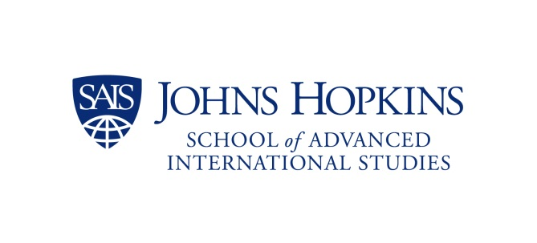

Iraq’s Economy: Challenges and Opportunities
AGENDA

08.30 a.m. - 09.30 a.m. Registration and light breakfast

09.30 a.m. Opening remarks
Introduction by:
- Sasha Toperich, Senior Fellow and Director, Mediterranean Basin Initiative, CTR-SAIS
- Michael J. Delaney, Assistant U.S. Trade Representative for South Asia
- Lukman Faily, Ambassador of the Republic of Iraq to the United States

10 a.m. - 11.15 a.m. Economic Mosaic of Iraq
Speakers:
- Joseph S. Pennington, Deputy Assistant Secretary of Iraq, Bureau of Near Eastern Affairs, U.S. Department of State
- Noori Abdulrahman, Chairman, Board of Investment and Minister of Coordination and Follow Up, Kurdistan Regional Government
- James Parks, Financial Advisor to the KRG Deputy Prime Minister

Commentator:
- Mark Kimmitt, Brigadier General (U.S. Army, ret.)

Moderator:
- Andrew Parasiliti, Director, Center for Global Risk and Security, RAND Corporation

11.15 a.m. - 11.30 a.m. Coffee break

11.30 a.m. - 12.45 p.m. Centralization or Decentralization of Iraq's Economic and Commercial Policy
Speakers:
- Bayan Sami Abdul Rahman, Kurdistan Regional Government Representative to the United States
- Sami Al-Araji, Head of the Iraq National Investment Commission (Via Skype)
- Justin Carney, Regional Vice-President, Middle East North Africa at Business Impact Networks

Moderator:
- Daniel Serwer, Professor and Director, Conflict Management Program, and Senior Fellow, CTR at SAIS

12:45 p.m. - 1.15 p.m. Doing Business in Iraq

- Iraq Commercial Office, Embassy of the Republic of Iraq in Washington, D.C.

12.30 - 12.45 p.m. Speech:

- Jasim Husein, Commercial Attache', Iraq Commercial Office, Embassy of the Republic of Iraq

12.45 - 1 p.m. Presentation:

- Qasim Basry, Executive Assistant, Iraq Commercial Office, Embassy of the Republic of Iraq

1.15 p.m. - 2.30 p.m. Lunch Break

2.30 p.m. - 4 p.m. Business Challenges and Opportunities
Speakers:
- Steve Lutes, Executive Director, Middle East Affairs, U.S. Chamber of Commerce
- Ginger Cruz, CEO, Mantid International LLC
- Rebwar Berzinji, Founder and President, Pericles Capital Advisors, LLC

Moderator:
- Sasha Toperich, Senior Fellow CTR at SAIS

4 p.m. - 5.15 p.m. Economic Growth and Trade Competitiveness Through Job Creation and SME's
Speakers:
- Zainab Allawi, Advisor to Executive Director, The World Bank
- Marc Tejtel, Deputy Chief Counsel for the Commercial Law Development Program (CLDP), US Department of Commerce
- Christopher Schroeder, Venture Investor and Author, Startup Rising: The Entrepreneurial Revolution Remaking the Middle East

Moderator:
- Rebeen Pasha, Founder & President SDH/REbuild Iraq and Middle East Young Entrepenurs' Dreams

5.15 - 5.30 p.m. Coffee Break

5.30 p.m. - 6.45 p.m. Private Sector Growth - Strengthening Transatlantic Partnership
Speakers:
- John J. Sullivan, Mayer Brown LLP
- Jorge Restrepo, Managing Partner, New Frontiers Legal Consulting Services
- David M. Tafuri, Partner, Dentons US LLP and President of the US-Kurdistan Business Council

Moderator
- Sasha Toperich, Senior Fellow CTR at SAIS

6.45 p.m. Reception

