The Center for Transatlantic Relations
at the Paul H. Nitze School of Advanced International Studies
Johns Hopkins University
EU Center of Excellence Washington, DC

Transatlantic Leaders Forum

with
Atifete Jahjaga
President of the Republic of Kosovo

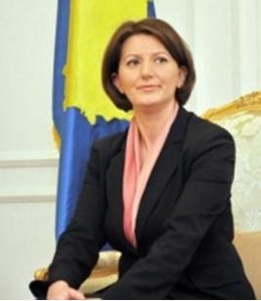

Kosovo’s President: What Does She Represent?

Daniel Serwer, Moderator
Senior Fellow
Center for Transatlantic Relations

When: Wednesday, December 14, 2011
Time: 10:00 AM – 11:30 AM
Where: Kenney auditorium, 1740 Massachusetts Ave., NW, Washington DC

