

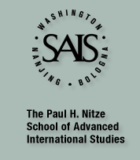

**Ukraine Policy Forum -  Tuesday, June 28, 12-13.30**

**Current Ukrainian Foreign and Security Policy**

 The Ukraine Policy Forum (UPF) at CTR, SAIS, was launched in February 2011.  Each Ukraine Policy Forum session will be a total of 1.5 hours divided between two speakers giving short presentations followed by discussion. Each UPF is by invitation only and all sessions are off the record.A light lunch will be served.

**\*\*\*Please RSVP by Friday, June 24 to Taras Kuzio (**[**tkuzio1@jhu.edu)\*\*\***](mailto:tkuzio1@jhu.edu%29***)

Center for Transatlantic Relations, School of Advanced International Studies, Johns Hopkins University,

Room 714, 1717 Massachusetts Avenue, NW

Washington, D.C. 20036

**The June 2011 UPF will feature two Guest Speakers and former Ambassadors to Ukraine**

**Steven Pifer is Senior Fellow, Foreign Policy, Center on the United States and Europe, Director, Arms Control Initiative, Brookings Institution**

**William B.Taylor is Vice President, Center for Post-Conflict Peace and Stability Operations, United States Institute for Peace**