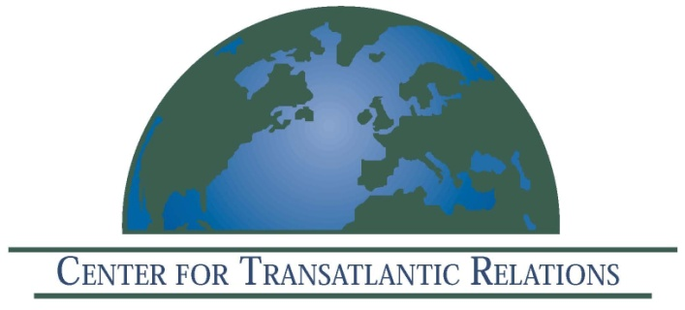
The Center for Transatlantic Relations, Johns Hopkins University--EU Center of Excellence
Invites you to a discussion on

International Law and Terrorism
European and American Perspectives

December 6, 2011
2:00 - 4:00 pm
Kenney Auditorium
The Paul H. Nitze School of Advanced International Studies
1740 Massachusetts Avenue, NW
Washington, DC 20036

Featuring
The Honorable John Bellinger
Partner, Arnold and Porter LLP
Former Legal Advisor, U.S. Department of State

His Excellency
Ambassador Peter Taksøe-Jensen
Embassy of the Kingdom of Denmark
Former Legal Advisor, Danish Foreign Ministry

Dr. Amitai Etzioni
George Washington University

Moderated by
Ambassador Kurt Volker
Senior Fellow and Managing Director
Center for Transatlantic Relations

Global terrorist organizations, which can exist separately from state sponsorship, yet can inflict damage on societies at the level of a state actor, are a new element in international security unforeseen when the current foundations of international law were developed. As a result, states in the international community have adopted a variety of approaches - from a domestic criminal framework (as in many European states) to the law of armed conflict. Yet issues such as "drone attacks," "renditions," off-shore detentions, and detainee treatment issues continue to generate serious political and legal questions. Here these experts address this complex web of questions in a thoughtful and rigorous public dialogue.

