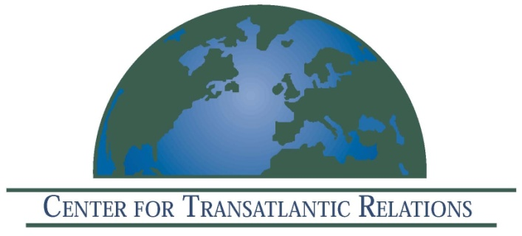

The Center for Transatlantic Relations, Johns Hopkins University
Center for International Peace Operations (ZiF)
German Institute for International and Security Studies (SWP)
German Council on Foreign Relations (DGAP)
Institute for European Studies, Free University Brussels

Invite you to attend a Book launch event

Preventing Conflict, Managing Crisis
European and American Perspectives
Edited by
Eva Gross, Daniel Hamilton, Claudia Major, Henning Riecke

How effective have recent international efforts at preventing conflict and managing crisis been such efforts been, and how could they be improved? What are the most effective means by which transatlantic efforts could be achieved? How may other partners best be engaged? The practitioners and experts in this volume offer recommendations and apply them to specific case studies. In addition, we offer the Crisis Management Toolbox, which outlines the key principles, actors and instruments guiding such efforts -- an invaluable resource for anyone interested in these issues. Copies of the book will be available.

December 6, 2011

9:15 am–12:30 pm

Location: Rome Auditorium
1619 Massachusetts Ave NW, Washington, DC

9:15 am Panel I: Challenges to EU-U.S. Cooperation in Crisis Management

- Transatlantic Approaches and Future Trajectories

Eva Gross, Institute for European Studies, Free University Brussels

- Why the EU Struggles with Civilian Crisis Management
Claudia Major, German Institute for International and Security Affairs

- From Afghanistan to the Arab Spring: A Critical Moment for Transatlantic Crisis Response
Glenn Nye, German Marshall Fund of the United States

- Post-Conflict Institution-Building and Governance: Lessons from Afghanistan
Federigi Bindi, University Tor Vergata/Center for Transatlantic Relations

10:45 am Keynote Speech: Failed States and the International Community 10 Years After 9/11: A Shifting Paradigm?

John Herbst, Director, Center for Complex Operations (CCO), National Defense University; former Coordinator for Reconstruction and Stabilization (S/CRS), U.S. Department of State*

11.15 Panel II: Conflict Prevention and Crisis Management – Principles, Actors, Instruments
- The Crisis Management Toolbox—From Civilian Crisis Prevention to Peacebuilding
Claudia Major, German Institute for International and Security Affairs

- The EU, the UN, and Other Key Actors – International Organizations in Conflict Prevention and Crisis Management
Karsten Geier, EU Mission to the United Nations

- Prospects for Preventing Conflict and Managing International Crises
P. Terrence Hopmann, SAIS Professor of International Relations and Director of the Conflict Management Program

12.30 Conclusion and Buffet Lunch
*author/invited

