Energy and Transportation in the Atlantic Basin:
Implications for the European Union and Other Atlantic Actors

Speaker Biographies

July 20th, 2017
Rome Auditorium, Johns Hopkins SAIS
1619 Massachusetts Ave NW, Washington, DC 20036
 | Natalia Soler-Huici  Natalia Soler-Huici is a research professor at the University of Reykjavik and research fellow at the Barcelona Centre for International Affairs (CIDOB).

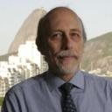  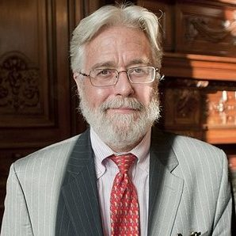 | Renato Flores, Professor at the Graduate School of Economics (EPGE)  Renato Flores is the Head of the International Intelligence Unit at Getulio Vargas Foundation, located in Rio de Janeiro. He is also the current director of the Jean Monnet Network Project on Atlantic Studies.  Paul Isbell, Senior Fellow at the Center for Transatlantic Relations (CTR), at Johns Hopkins University, School of Advanced International Studies  Paul Isbell is a Senior Research Associate at the Elcano Royal Institute for International and Strategic Studies in Madrid. He has been a leading researcher in the CTR’s Atlantic Basin Initiative, and the research director for its “Atlantic Energy Forum.” He has taught energy and geopolitics, international economics and global affairs at numerous leading universities across the Atlantic Basin such as: George Washington University, Syracuse University, ICADE-Pontificia Comillas, University of Alcala de Henares, and the Technological Institute of Buenos Aires-ITBA. Paul has worked as an emerging market economist for Banco Santander and as a private consultant for regional development banks, international NGOs, research institutions, and private companies in the fields of energy, land-use, climate change and geopolitics. Currently, he is the leader of the energy component of the Jean Monnet Network Project on Atlantic Studies
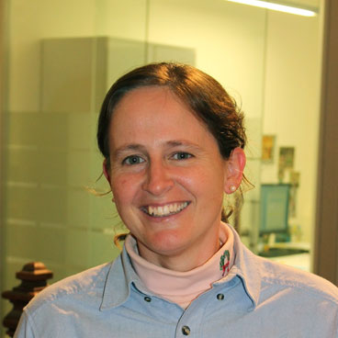 | Macarena Larrea  Macarena Larrea holds a Ph.D. in Business Advertising and Development from the University of the Basque Country, she wrote her thesis on the “Internalization of the External Costs of Electricity Production”. Her research is centred mainly on energy and climate issues, such as the energy sector, and energy, climate and industrial policies, especially within Europe and Spain. She has gained experience at the University of the Basque Country, as well as at Orkestra.  Macarena has participated in projects whose goal includes the progress of energy policies regarding the challenges for the future, especially in the area of electricity, which covers the energy taxation system and reform of electricity in Spain. She has also taken part in various projects together with public institutes of the Basque Country.  She has a Master's Degree in Management of Port and Maritime Businesses run by the University of Deusto in conjunction with the Basque Country School of Maritime Administration, and has a Degree in Business Administration and Management, specializing in Logistics and Technology. She was awarded a Professional Qualification grant in the areas of European Matters and Inter-regional Cooperation from the Basque Country General Secretariat of External Action.
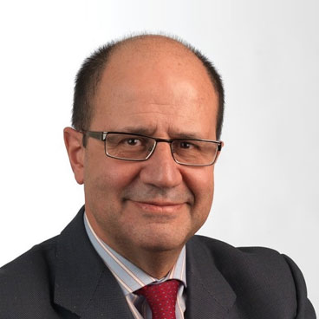 | Eloy Álvarez Pelegry, Director of the Energy Chair at Orkestra, the Basque Institue of Competitiveness, located at Duesto University in Bilbao, Spain  Dr. Álvarez received his PhD in Mining from the Higher Technical School for Mining of Madrid (ETSIMM). He holds a bachelor’s Degree in Economics and Business from the Complutense University of Madrid, and a Diploma in Business Studies from the London School of Economics. Devoted to the field of energy, Dr. Álvarez’s career consists of a long and intense executive background at Union Fenosa in Spain as Director of Corporate Intelligence in Gas Natural Fenosa; Director of Quality, Environment, Research and Development; Director of Fuels; and Director of Planning, Economics, and Control.  He has also built a parallel career in the academic field as an Associate Professor at the Higher Technical School for Mining of Madrid (ETSIMM), the Complutense University of Madrid, and served as an Academic Director for the Spanish Energy Club, and Duesto University. He is a member of the World energy Resources Study Group Meeting of the World Energy Council (WEC) and is a member of the European Science and Technology Network on Unconventional Hydrocarbon Extraction Working Groups 1 and 2 in Brussels. Dr. Álvarez is a member of the Energy Group of the Elcano Royal Institute and of the Carbon Capture and Sequestration Committee of the world Energy Council. He has published over 35 articles, various books, given over 100 public presentations and was named to the Real Academy of Engineering in 2012.
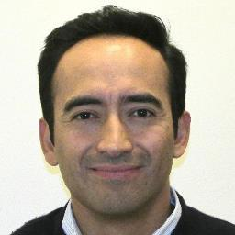 | Ernesto Monter, Lead Transportation Specialist at the Inter-American Development Bank, Washington D.C.  A Mexican citizen possessing over 20 years of extensive experience working in the analysis of environmental issues in both the public and private sectors, Mr. Monter holds an Environmental Engineer degree from the Autonomous Metropolitan University in Mexico and a Masters in Environmental Sciences and Policy from John Hopkins University. He has spent most of his career assessing environmental aspects and seeking solutions to address adverse environmental impacts related to complex and challenging projects. Mr. Monter joined the Inter-American Development Bank (IDB) in 1999, upon working in the Private Sector Department, the Environment and Safeguards Unit. Prior to becoming the current Lead Transport Specialist in the IDB's Transport Division, Mr. Monter worked as a Project Manager in the international environmental consulting firm, Dames & Moore in Mexico, and held different positions in the Mexican government, including special advisor to the Mexico City Environmental Secretariat, where he coordinated some initiatives to improve ambient air quality in the Mexico City Metropolitan Area.
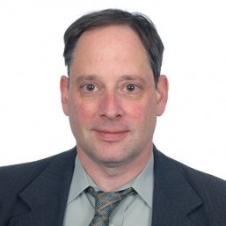 | Roger Gorham, Transport Economist and Urban Development Specialist, World Bank  With over 20 years of experience in urban transport, land-use, air quality, and climate change, Roger Gorham focuses on Latin America and the Caribbean, with projects in Ecuador and Haiti. Until recently, he worked extensively in Africa, working on urban transport projects in cities such as: Lagos, Addis Ababa, and Nairobi. He also worked extensively with the Africa Transport Policy Program (SSATP), on urban transport and sustainability policy. He has led efforts on behalf of the Bank and SSATP, in concert with the United Nations Environment Program and others, to support the establishment of an Africa Sustainable Transport Forum, whose inaugural meeting in October 2014 was sponsored by the Kenyan government.  Prior to joining the World Bank, Mr. Gorham worked as a transport, climate change, and air quality specialist with the US Environmental Protection Agency, and has been a consultant for a range of international and private sector organizations, including the International Energy Agency, the International Transport Forum, and the Inter-American Development Bank. He authored numerous publications and reports, including “Air Pollution from Ground Transportation” (United Nations 2002) and “Flexing the Link between Transport and Greenhouse Gas Emissions” (International Energy Agency 2000). Mr. Gorham holds a Master of City Planning and Master of Transportation from the University of California at Berkeley and currently lives in Washington, DC with his wife and two children.
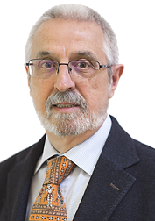 | Jordi Bacaria, Director of the Barcelona Centre for International Affairs (CIDOB)  As the Director of CIDOB, the lead institution in the recent Atlantic Future project of the European Union, Jordi Bacaria holds a degree in Economics (1975) and a PhD in Economics (1981) from the Autonomous University of Barcelona (UAB). From 2000 he has been co-director of the Institute for European Integration Studies in Mexico, an institution funded by the European Commission and the Autonomous Technological Institute of Mexico.  Since February 2009, he has been the director of the journal “Foreign Affairs Latinoamérica" published in Mexico. He is a member of FEMISE (Euro-Mediterranean Forum of Economic Science Institutes) and evaluator of ANECA (National Agency for Quality Assessment and Accreditation of Spain). He has been Dean of the Faculty of Economics at the UAB (1986-1988) and director of the Institute for European Studies (1988-1992, 1994-2000). From 2000 to 2009, he coordinated the Doctoral Program in International Relations and European Integration of the UAB and authored publications on economic integration, Latin America, Mediterranean economy, monetary institutions and public choice.
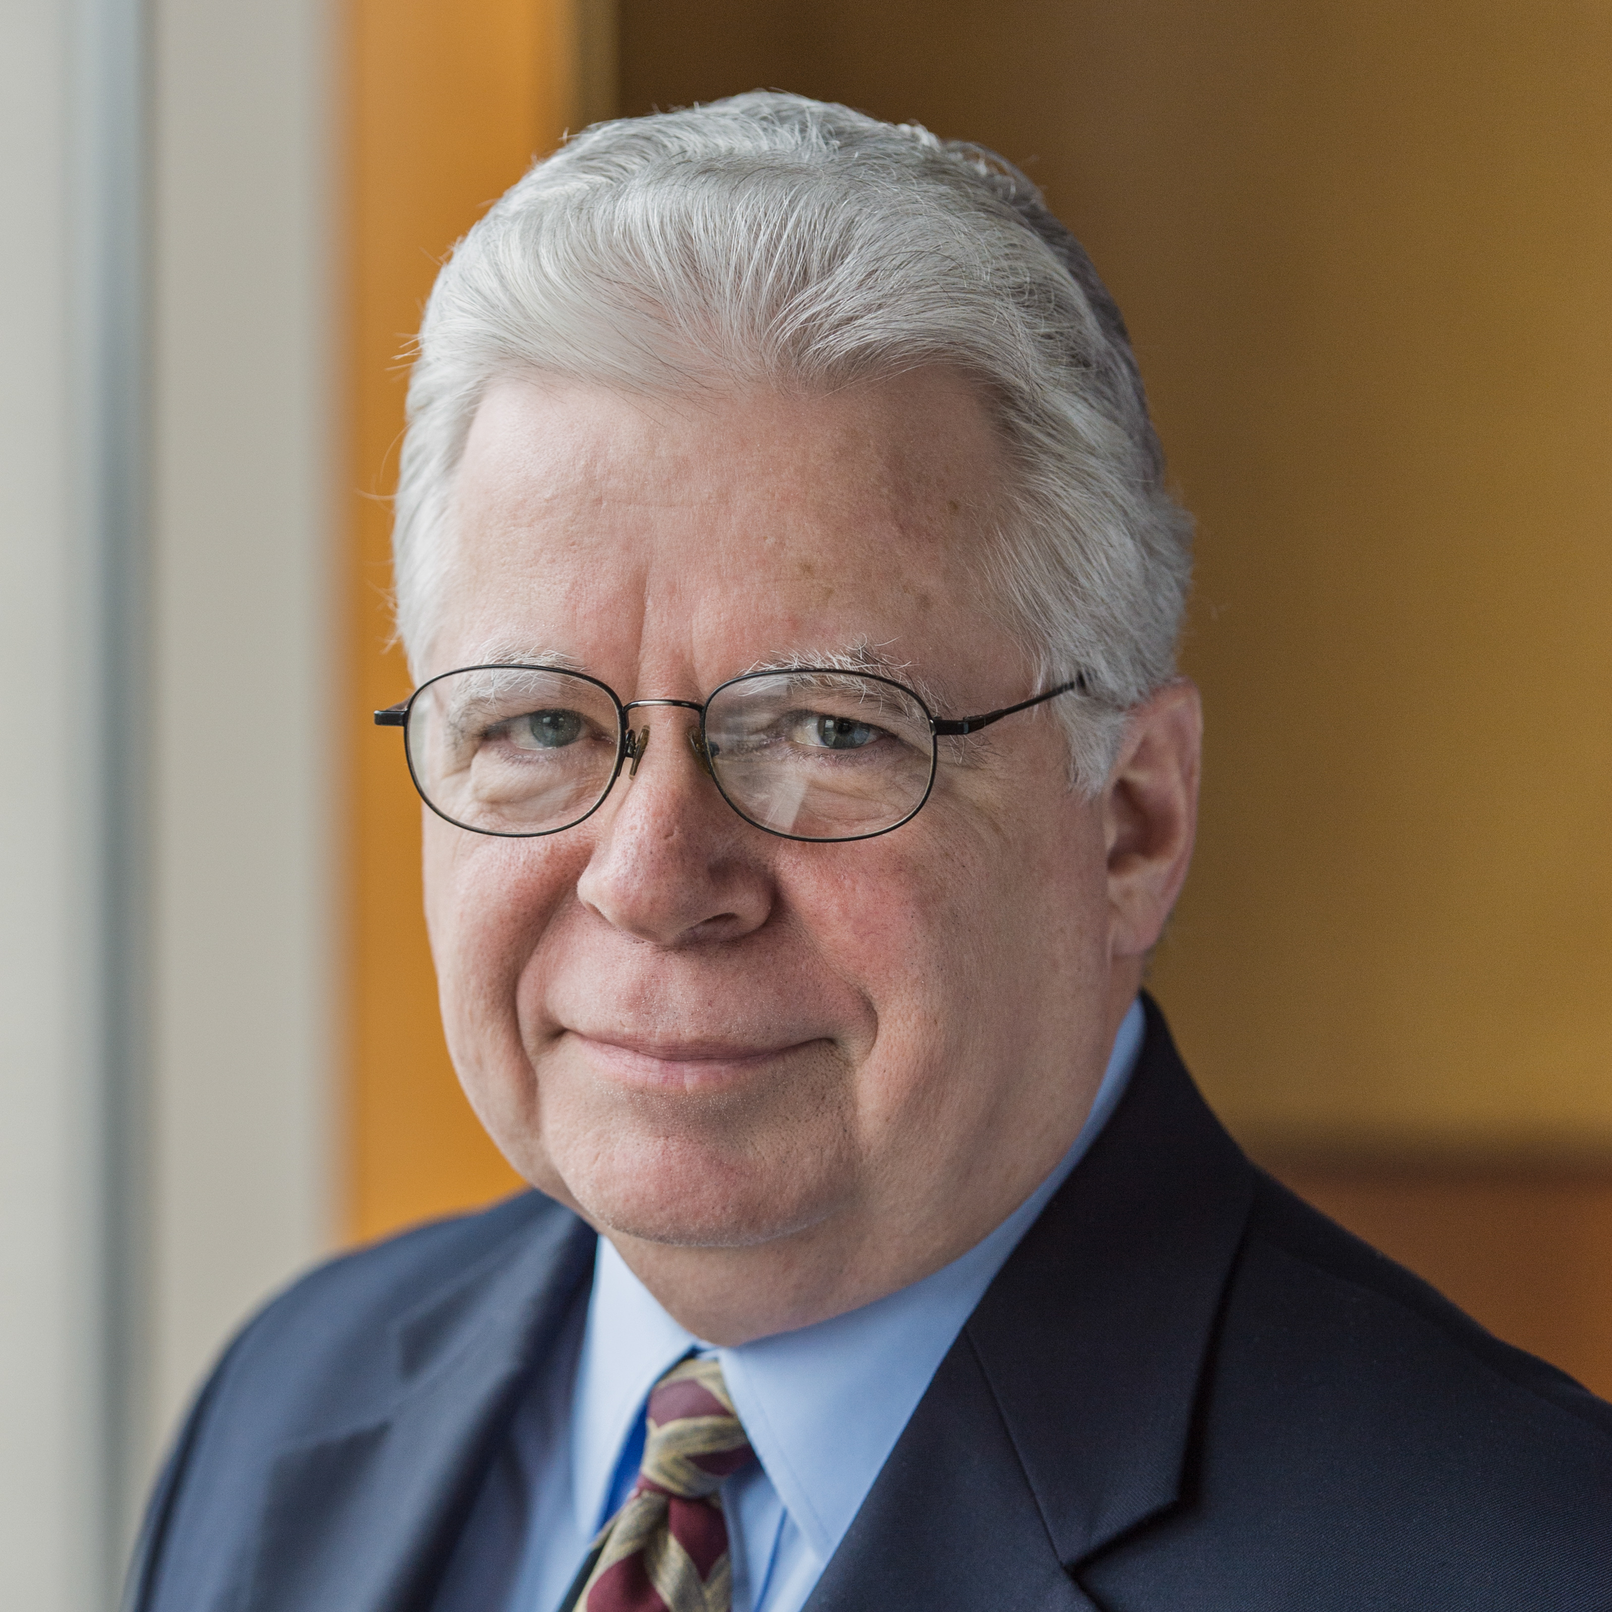 | Martin Lowery, Executive Vice President and Member for the Association Relations of the National Rural Electric Cooperation Association (NRECA)  Martin Lowery has been a forceful advocate for the cooperative business model for more than three decades, with an unshakable conviction that enabling people to empower themselves represents the best was to improve the quality of their lives.  As, Executive Vice President and Member for the Association Relations of the National Rural Electric Cooperative Association (NRECA), his responsibility is to ensure that NRECA excels in meeting the needs of its 1,000 member cooperatives. Beginning in 1982, his career at NRECA includes managing NRECA's Consulting, Training and Market Research Division, providing essential management services to the NRECA membership. Martin serves on the National Cooperative Business Association (NCBA) board and is a past Chair, serves on the board of the National Cooperative Bank (NCB), the Ralph K. Morris Foundation board and is the U.S. representative to the International Cooperative Alliance (ICA) board. Martin has devoted his professional life to promoting and advocating for the cooperative way of doing business.  He has spoken extensively in the U.S. and around the world on behalf of cooperatives, was instrumental in the creation of the Touchstone Energy Cooperatives brand used today by most electric cooperatives and provided leadership in the creation of the first electric cooperative in the state of Hawaii, Kauai Island Utility Cooperative. His passion for cooperatives extends to supporting economic development in global emerging economies across all cooperative sectors. Martin was recognized at the annual Cooperative Hall of Fame Dinner and Induction Ceremony at the National Press Club in Washington, DC on Wednesday, May 7, 2014.
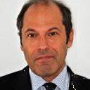 | João Fonseca Ribeiro  As a Portuguese Navy officer with 25 years of service, most of which has been dedicated to naval operations, in deployed combined forces, communications and information systems, and international and interdepartmental cooperation and collaboration. He has participated in live operations in the Balkans, the Eastern Mediterranean and Africa.  On land, he was the Portuguese national representative to the Allied Command for Transformation, as well as to the Command of the Joint Forces of the US, both in Norfolk, VA. He has held many high level posts within the Portuguese Navy and government, including as Division Chief for Operations and External Relations of the Navy and as Secretary of State for the Sea in the Portuguese Ministry of Agriculture, the Sea, Environment and Territorial Order.  He has also been a key figure in the design of Portugal’s national maritime strategy and a national representative at many organizations and governance bodies dedicated to the sea and the Atlantic, in particular. Currently, he is the CEO of Blue Geo Lighthouse, a firm dedicated to the maritime infrastructures of the Atlantic.



